Cultural and Linguistic Diversity

Our Action Plan

2024–2028
Easy Read version

How to use this Action Plan
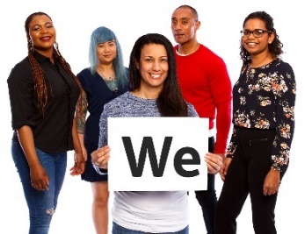 | The National Disability Insurance Agency (NDIA) wrote this Action Plan.  When you see the word ‘we’, it means the NDIA.
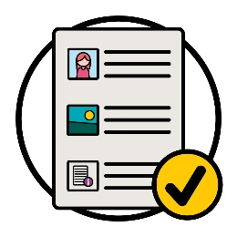 | We wrote this Action Plan in an easy to read way.  We use pictures to explain some ideas.
We wrote some important words in bold.
This means the letters are thicker and darker.
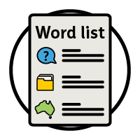 | We explain what these words mean.  There is a list of these words on page 47.
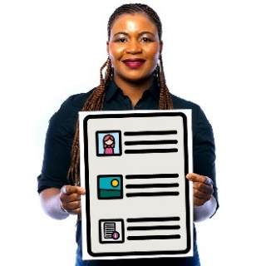 | This is an Easy Read version of the Cultural and Linguistic Diversity Action Plan 2024–2028.
You can find the Cultural and Linguistic Diversity Action Plan 2024–2028 on our website.
www.ndis.gov.au/CALD
You can ask for help to read this Action Plan.
A friend, family member or support person may be able to help you.
 | This is a long document.
You do not need to read it all at once.
You can take your time
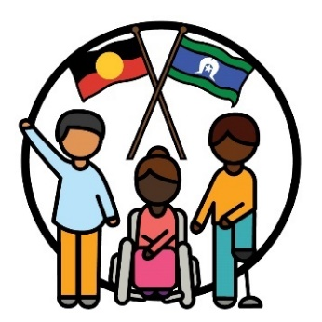 | We recognise Aboriginal and Torres Strait Islander peoples as the traditional owners of our land – Australia.
They were the first people to live on and use the:
- lands
- waters.

What is in this Action Plan?
What does CALD mean? 5
About our Action Plan 7
1. Focusing on CALD participants when we work 8
2. Making sure our staff have the right skills 16
3. How we share information 23
4. Choice and control 31
5. Data about CALD participants 37
6. How we connect with the community 40
More information 45
Word list 47

What does CALD mean?
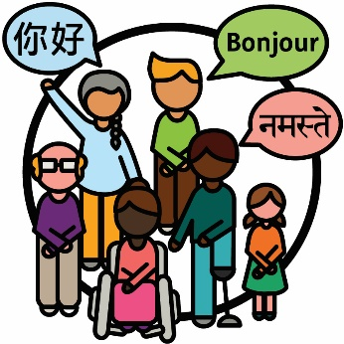 | Culturally and linguistically diverse (CALD) people are people who:  - come from different backgrounds  - speak languages other than English.
 | In Australia:
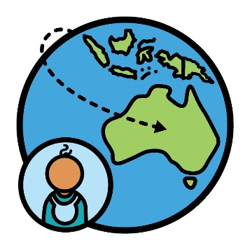 | - there are close to 8 million people who were born overseas
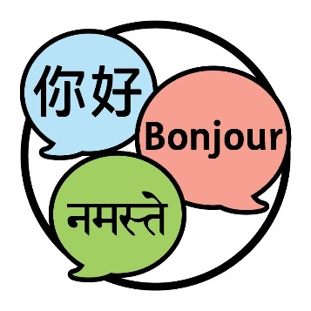 | - people speak more than 300 different languages.

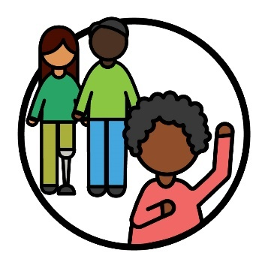 | When you identify as something, you are saying that you belong to a certain group of people.
 | 30% of people who live in Australia identify as a CALD person.
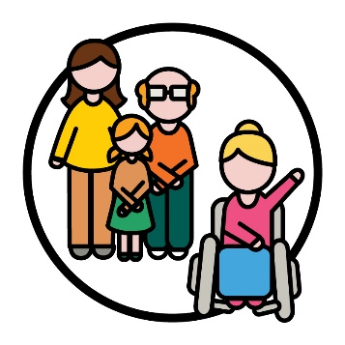 | 10% of participants in the National Disability Insurance Scheme (NDIS) identify as a CALD person.
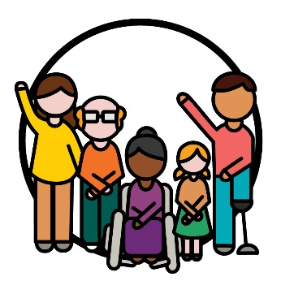 | Participants are people with disability who take part in the NDIS.

About our Action Plan
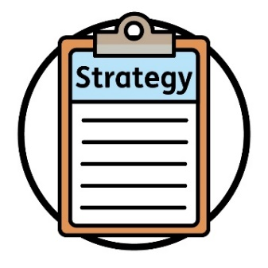 | We wrote the new Cultural and Linguistic Diversity Strategy 2024–2028.  We call it the Strategy.  The Strategy is a plan for how we will make the NDIS better for CALD participants.
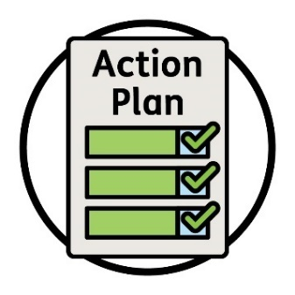 | This Action Plan explains what we will do to support the Strategy.
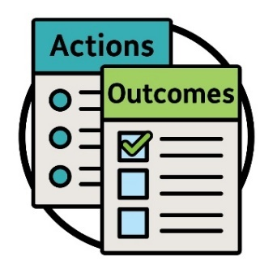 | It explains the:  - actions we will take  - outcomes we want.  Outcomes are the ways our work changes people’s lives.
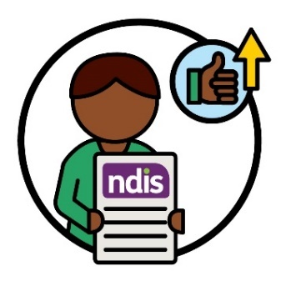 | We want to have better outcomes that improve the experiences participants have with the NDIS.
 | This Action Plan also explains how we will know if the actions work.

1. Focusing on CALD participants when we work

Action 1
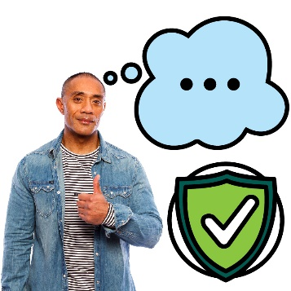 | We will work with others in the community to make sure everyone knows what some important words mean in the NDIA.  We will also make sure these words are safe for all cultures.
Your culture is:
- your way of life
- what is important to you.
 | We will make sure everyone knows what the words cultural safety mean.
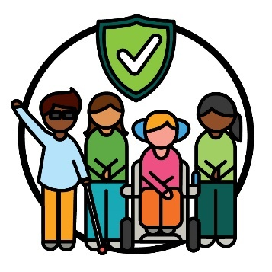 | Cultural safety is when we:  - respect people’s culture  - make people feel safe  - help people feel like they belong.
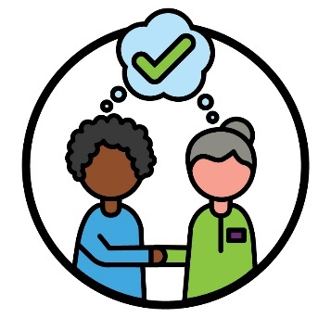 | We will also make sure everyone knows what the words culturally appropriate and responsive service mean.  Culturally appropriate and responsive service is when services respect the cultures and beliefs of the people who use them.
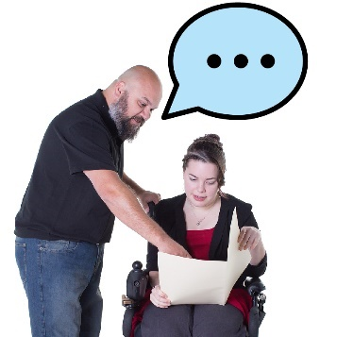 | We will make sure we use these words in:  - the information we share  - the ways we support participants.
We will also make sure that our staff and NDIS partners understand what these words mean.
NDIS partners are people who help others find and use services.
In this Action Plan, we just call them our partners.
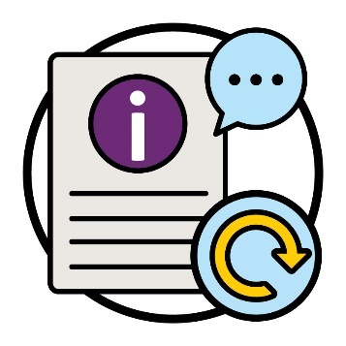 | We will update information and services to include words that are safe for all cultures.  We will check if this action is working by keeping track of what we update.

Action 2
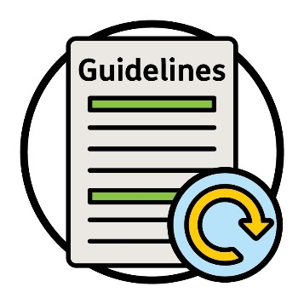 | We will update our guidelines about how the NDIS works.  We will include information on how to:  - be safe for all cultures  - use words participants understand  - be inclusive.
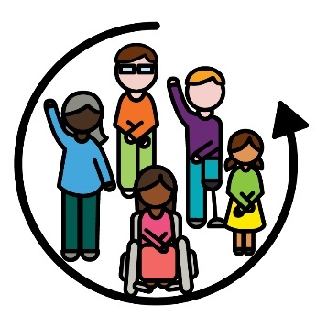 | When something is inclusive, everyone:  - can take part  - feels like they belong.
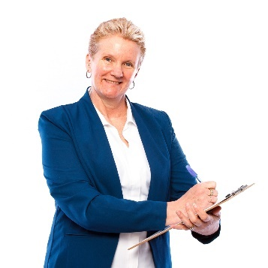 | We will check if this action is working by keeping track of:  - how many guidelines we update  - which guidelines support what CALD participants need.

Action 3
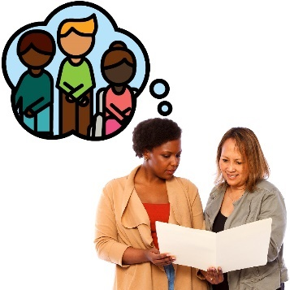 | We will support NDIA planners to better understand what CALD participants need.
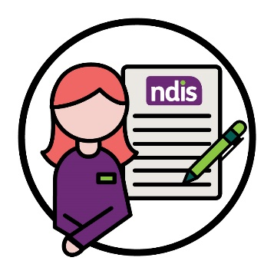 | An NDIA planner is someone who:  - makes new plans  - changes plans.
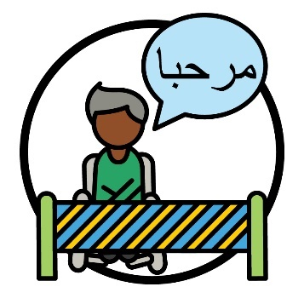 | This includes information on how to support CALD participants when language is a barrier.  A barrier is something that stops you from doing something you:  - need to do  - want to do.

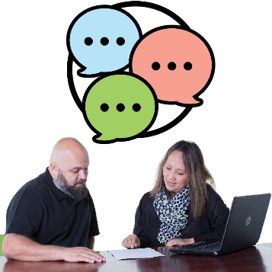 | We will make sure planners know how to find and use information in different languages.
 | We will check if this action is working by keeping track of how many CALD participants:
 | - use NDIS information in different languages
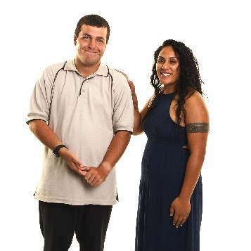 | - get the supports they need
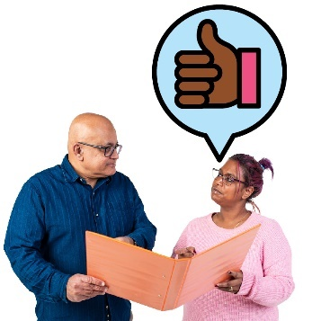 | - share they have had a good experience with their planner.

Action 4
We will share information with our staff and partners on how to support people who are new to Australia.
This includes support that is safe for refugees.
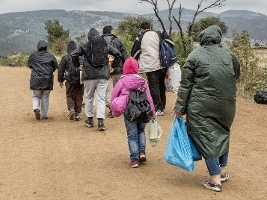 | A refugee is someone forced to leave their country:  - because of violence – when someone hurts you  - so they can stay safe.
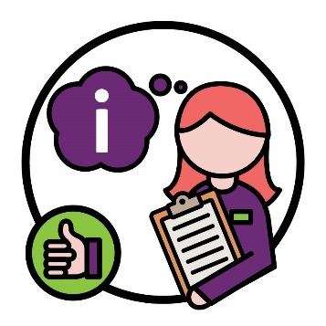 | We will make sure more our staff and partners can find and use this information.
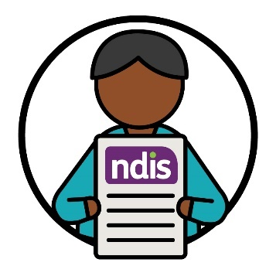 | We will check if this action is working by how many refugees and people who are new to Australia:  - take part in the NDIS  - use the NDIS.

Action 5
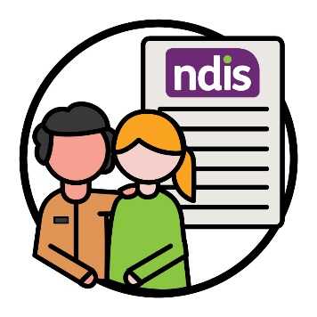 | We will work with other government organisations to better support people to take part in the NDIS.
This includes:
- refugees
- people who are new to Australia.
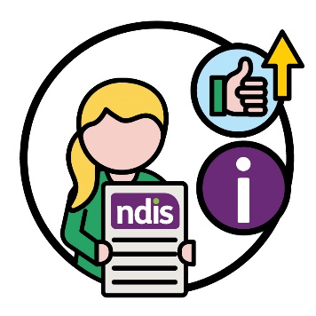 | We will use information about people who are new to Australia to make it easier for them to take part in the NDIS.  This includes assessments they have had done.
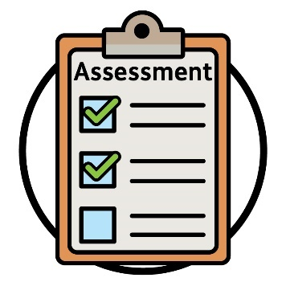 | Assessments are how we work out:  - how your disability affects your life  - what supports you need from the NDIS.
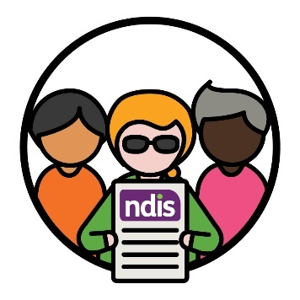 | We will check if this action is working by how many refugees and people who are new to Australia take part in the NDIS.

Action 6
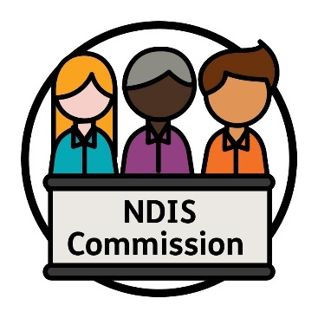 | We will work with the NDIS Quality and Safeguards Commission to make new rules for how we will work.  We call them the NDIS Commission.
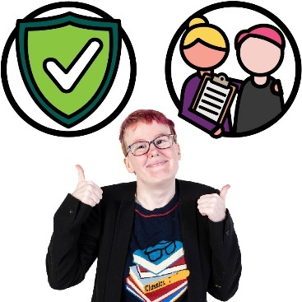 | The NDIS Commission makes sure people with disability who take part in the NDIS:  - are safe  - get good services.
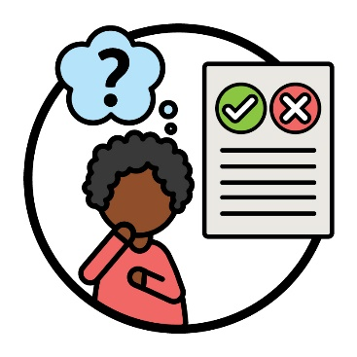 | These rules will help CALD people with disability:  - share their thoughts with us  - question decisions the NDIA makes.
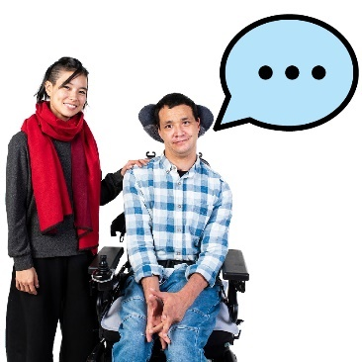 | We will work out the best way to support CALD people with disability to share their thoughts.
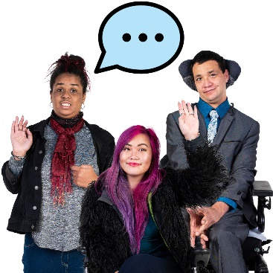 | We will check if this action is working by how many CALD people with disability share their experiences with us.

2. Making sure our staff have the right skills

Action 7
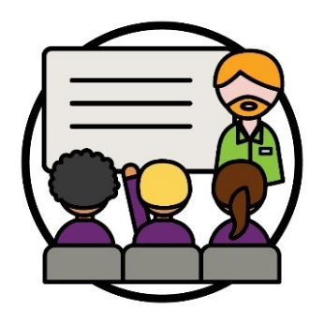 | We will make a new training program for our staff and partners.  We will work with community and government organisations to make this program.
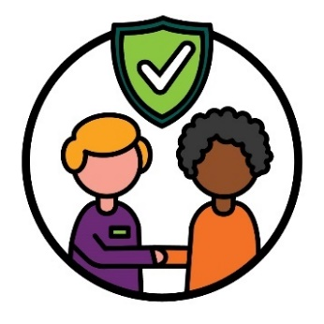 | The training will help our staff and partners learn how to connect in a safe way with CALD people.
 | We will check if this action is working by how many of our staff and partners:
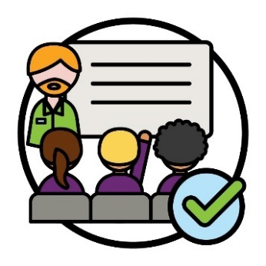 | - finish the training
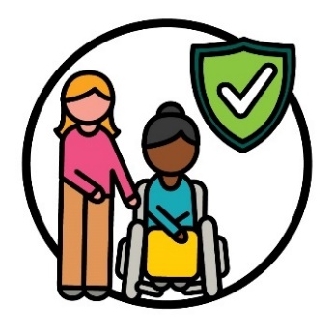 | - understand how to support people in ways that are safe for all cultures.
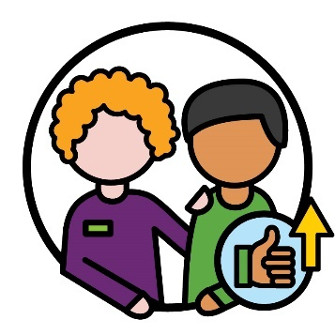 | We will also check if this action is working by CALD participants tell us they have better experiences with our staff and partners.

Action 8
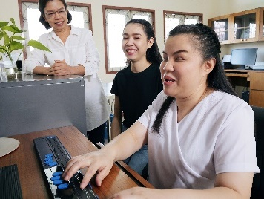 | We will support more CALD people to work for us.  This includes CALD people with disability.
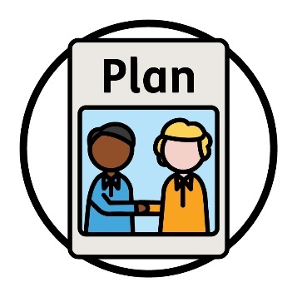 | We will also make a plan to share how we will hire more CALD staff.
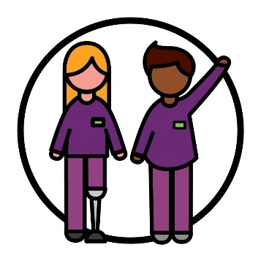 | We will check if this action is working by how many NDIA staff:  - have disability  - come from CALD backgrounds.

Action 9
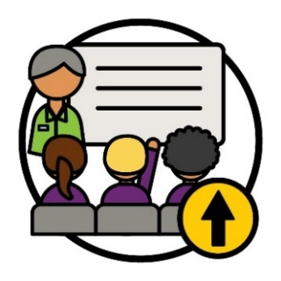 | We will work with others to deliver more training programs to our staff and partners.
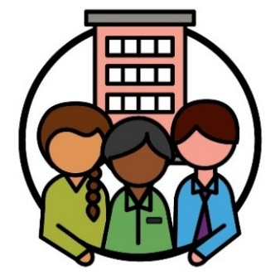 | We will work with community and government organisations to do this.
 | We will make sure this training helps our staff and partners know how to deliver supports that:
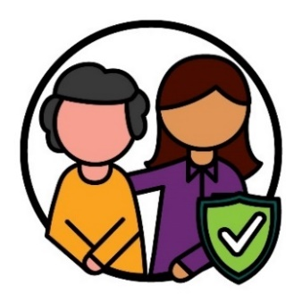 | - are safe for all cultures
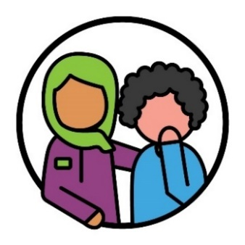 | - help people who have experienced trauma.
Trauma is the way you feel about something bad that happened to you.
For example, you might feel scared or stressed.
Trauma can affect people in different ways.
 | We will check if this action is working by how many:
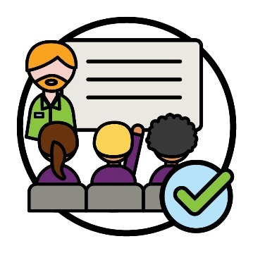 | - staff and partners finish this training
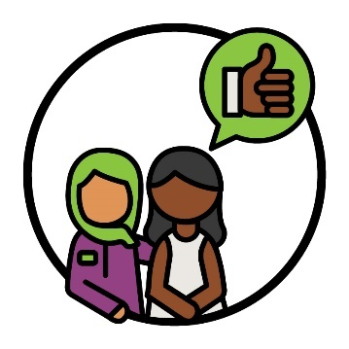 | - CALD participants share good experiences with our staff and partners.

Action 10
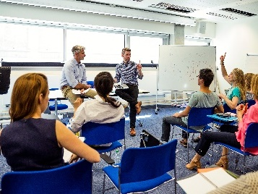 | We will train our staff and partners on how to use language supports.  This includes interpreters.
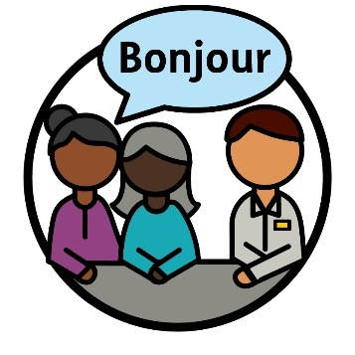 | An interpreter is someone who:  - uses your language  - helps you communicate with others  - helps you understand what someone is saying.

 | This will make sure our staff and partners:
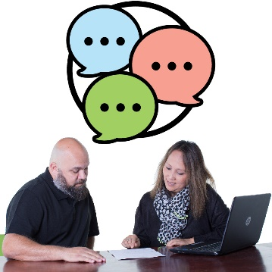 | - know how to find and use language supports
 | - communicate better with interpreters.
 | We will check if this action is working by keeping track of how many:
 | - staff and partners finish this training
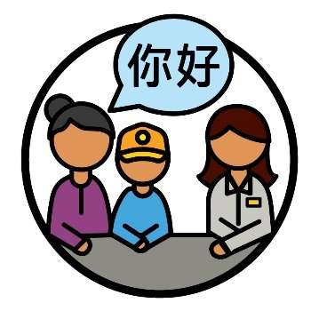 | - CALD participants use interpreter services.

Action 11
 | We will create a plan to make the NDIA a place to work that is:
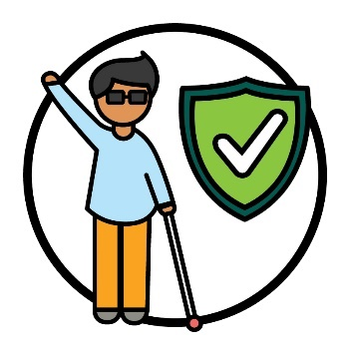 | - safe for all cultures
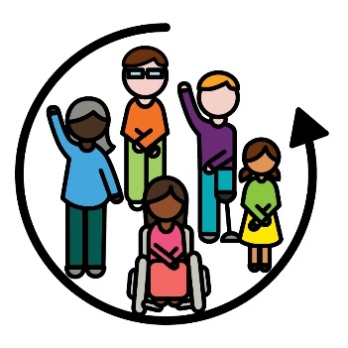 | - inclusive.
We will check if this action is working by how many CALD people:
- keep working for us
- are able to grow their career.
 | A career is the path you take in an area of work you choose.

Action 12
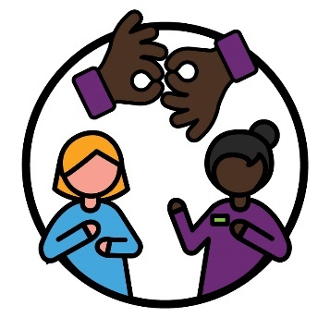 | We will make a group for our staff and partners to share their skills with other staff.  For example, skills such as Auslan.
 | This means we can better support people who are deaf or hard of hearing.
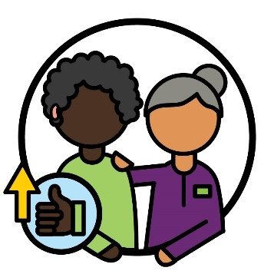 | We will check if this action is working by how many of our staff and partners get better at supporting people who are deaf or hard of hearing.
 | We will also check if this action is working by listening to what people who are deaf or hard of hearing share about:
 | - how well we support them
 | - how easy it is to find and use NDIS supports.

3. How we share information

Action 13
 | We will make new guidelines about how to:
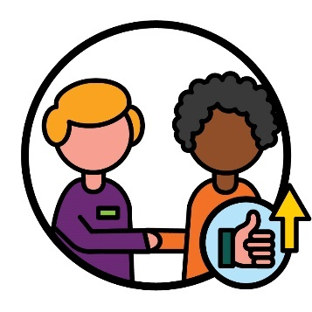 | - best connect with CALD people with disability
 | - share information in different ways.
 | To make these guidelines, we will work with:
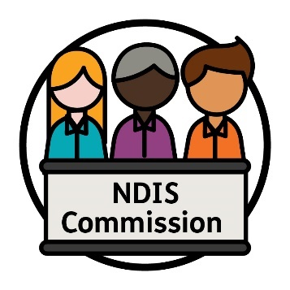 | - the NDIS Commission
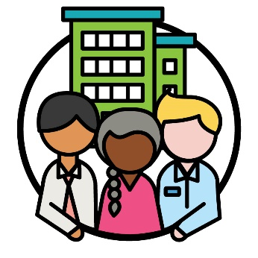 | - organisations that support CALD people with disability.

 | We will use these guidelines to better communicate with CALD:
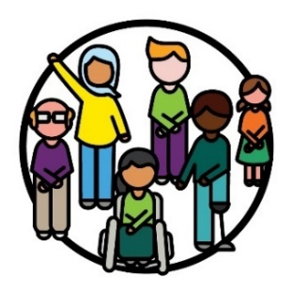 | - participants
 | - communities.
 | We will check if this action is working by listening to:
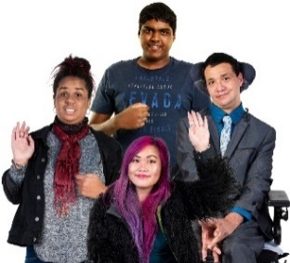 | - CALD participants
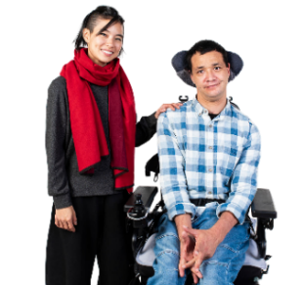 | - people who support CALD people with disability
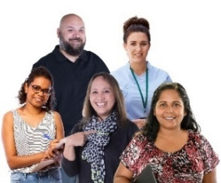 | - providers.
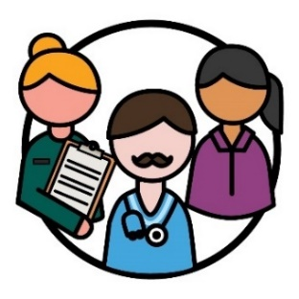 | Providers support people with disability by delivering a service.

Action 14
We will make it easier for CALD communities to use our online services.
For example, the NDIS website.
 | We will do this by:
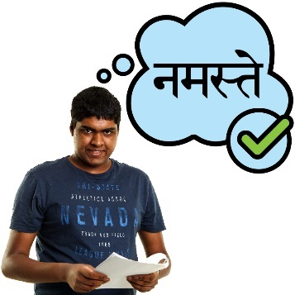 | - sharing information in languages CALD people understand
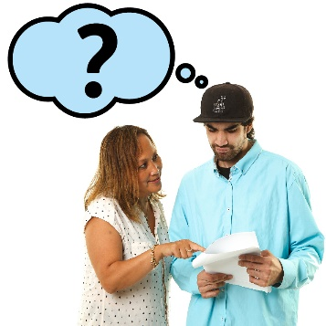 | - supporting CALD people when we share information in a language they do not know.
 | We will check if this action is working by how many more CALD people use our online services.

Action 15
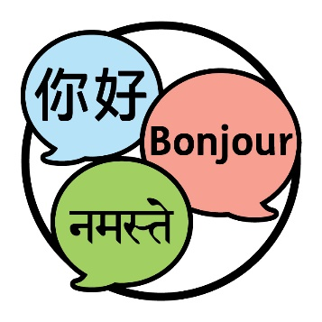 | We will make guidelines on what languages we need to share NDIS information in.  This means more CALD people can understand the NDIS.
 | To make these guidelines, we will work with:
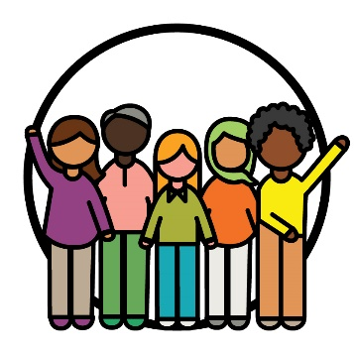 | - CALD communities
 | - the NDIS Commission
 | - organisations that support CALD people with disability.

 | We will check if this action is working by how many:
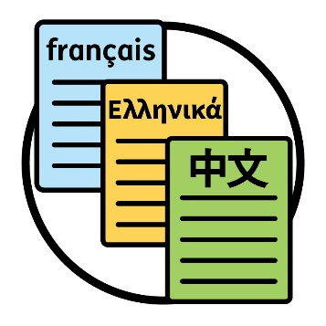 | - documents we share in languages that are not English
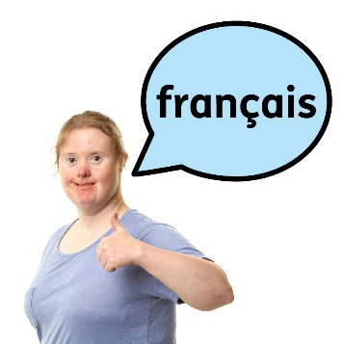 | - CALD people tell us they can find information about the NDIS in their language.

Action 16
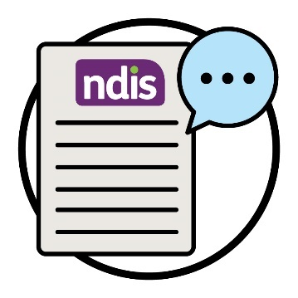 | There are certain words we use to explain the NDIS.  We will make resources in different languages to explain what these words mean.
 | This will help more people understand information about the NDIS.
 | It will also help interpreters to share NDIS information with CALD participants.
 | We will check if this action is working by how many interpreters:
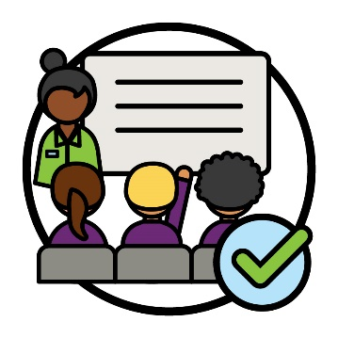 | - finish training to better understand the NDIS
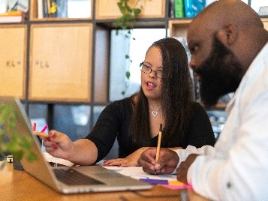 | - use our resources.

Action 17
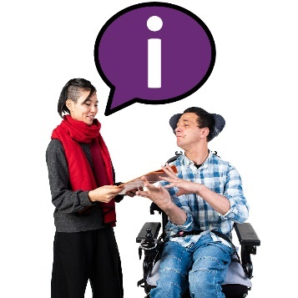 | We will share information with CALD people about how they can find and use interpreter services.

 | This includes CALD:
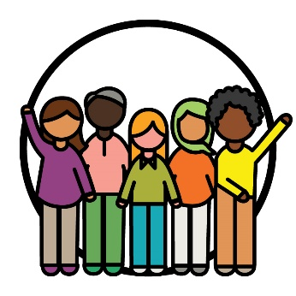 | - communities
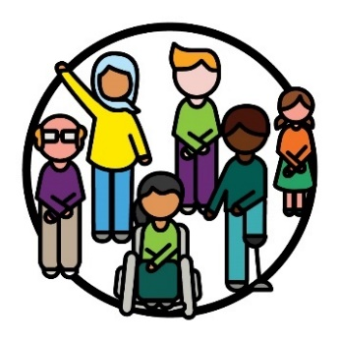 | - participants
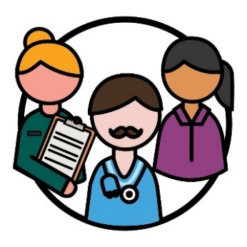 | - providers.
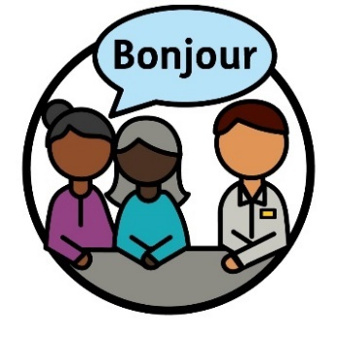 | We will check if this action is working by how often people use interpreter services.  This includes:  - CALD participants  - our staff and partners  - providers.
 | We will also listen to what they tell us about their experiences with these services.

Action 18
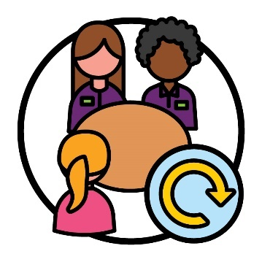 | We will update the way we plan and run meetings with CALD participants.  This includes:  - using interpreters CALD participants like  - having longer meetings.
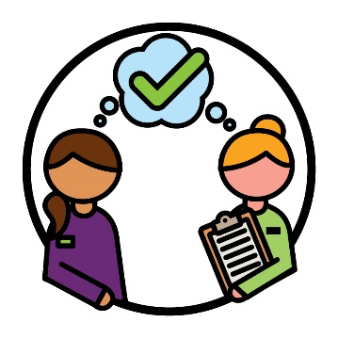 | We will make sure all our staff and partners understand how we plan and run these meetings.
 | We will check if this action is working by how many:
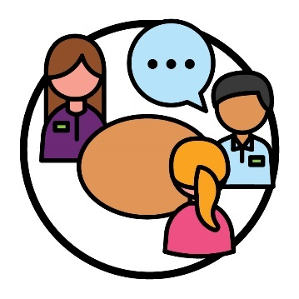 | - interpreters are used in meetings to support CALD participants
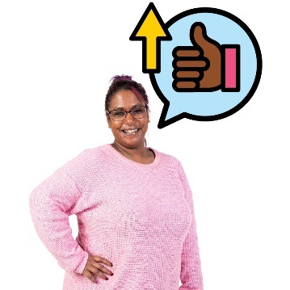 | - CALD participants tell us they have had a better experience with interpreters at their meetings.

4. Choice and control

Action 19
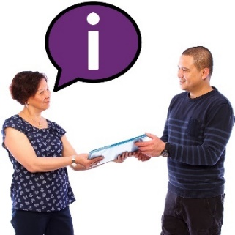 | We will work with the NDIS Commission to share information with providers.  This includes information about what providers need to do to make sure their services are safe for all cultures.
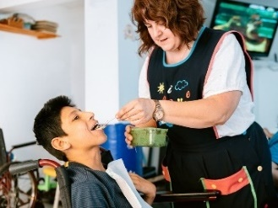 | This will mean more providers understand how to support CALD participants in the ways they need.
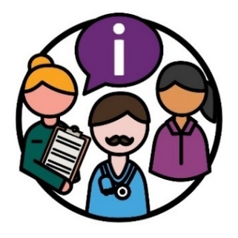 | We will check if this action is working by listening to what service providers have to say about the information.
 | For example, what they have to say about how well the information supports them to:
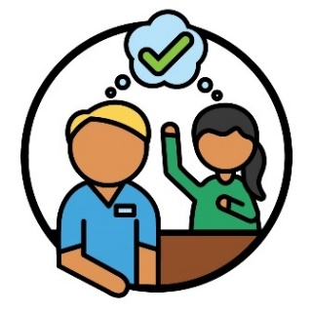 | - better understand the supports that CALD people need
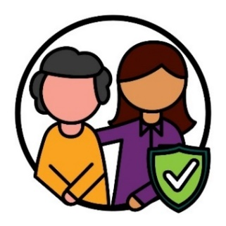 | - deliver safe services for all cultures.

Action 20
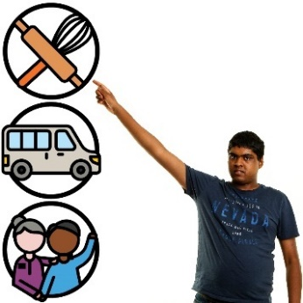 | We will work with the NDIS Commission to support CALD participants to have more choice and control.
 | This includes sharing information with CALD participants about how they can:
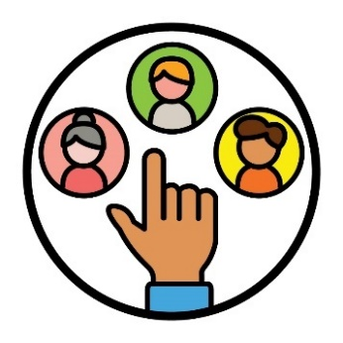 | - choose their own providers
 | - change their providers
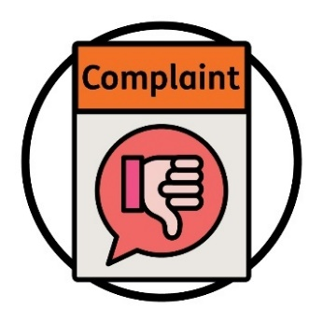 | - make a complaint.
When you make a complaint, you tell someone that something:
- has gone wrong
- is not working well.
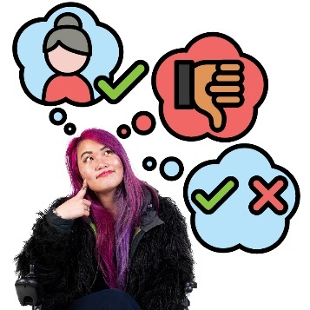 | We will check if this action is working by how many CALD participants share that they understand:  - how to know if a provider is right for them  - how to make a complaint  - their rights to choice and control.
Rights are rules about how people must treat you:
- fairly
- equally.

Action 21
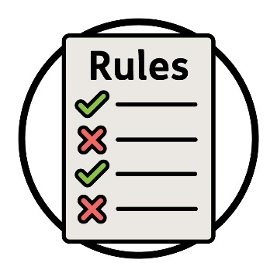 | We will work with the NDIS Commission to make new rules that providers must follow.

 | These rules will focus on how providers must offer services that:
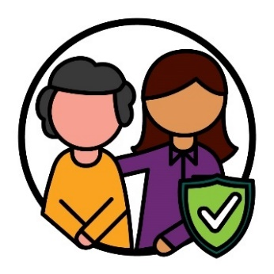 | - are safe for all cultures to use
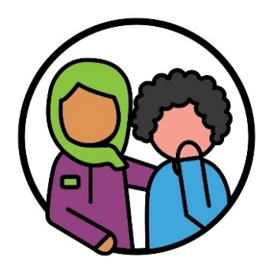 | - support CALD participants who have experienced trauma.
 | When we have made these rules, we will share them with providers and CALD participants.
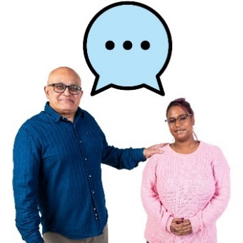 | We will listen to what providers and CALD participants have to say about how well the rules work.
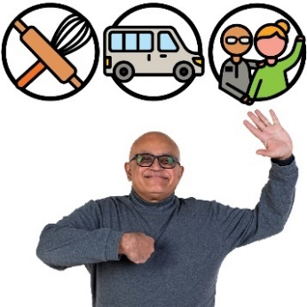 | We will check if this action is working by how many providers offer services that follow these rules.

Action 22
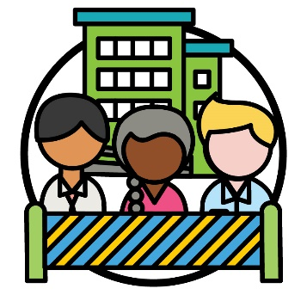 | We will look at the barriers that some organisations who support CALD people with disability face.  We will work with other government organisations to remove these barriers.
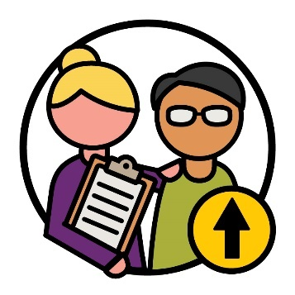 | We will make sure organisations who support CALD people with disability can deliver more NDIS services.
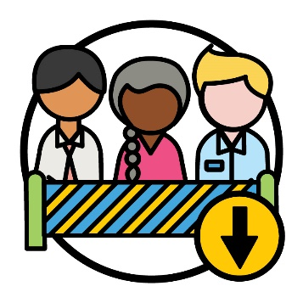 | We will check if this action is working by how many organisations experience less barriers.

Action 23
 | We will work with other government organisations to make sure more interpreters understand:
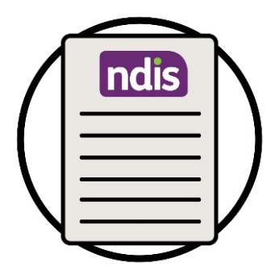 | - the NDIS
 | - the rights of people with disability.
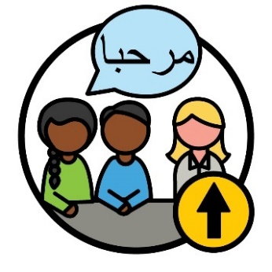 | We will make sure there are more interpreters who can support CALD participants.
 | We will also check how many programs there are to support interpreters.
 | We will check if this action is working by how many interpreters are available to support CALD participants with the NDIS.

5. Data about CALD participants

Action 24
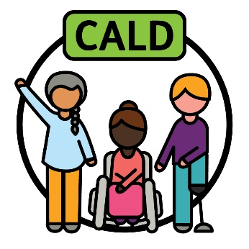 | We will work with others to agree on how we explain what ‘CALD’ means.
 | We will work with:
 | - CALD communities
 | - other government organisations.
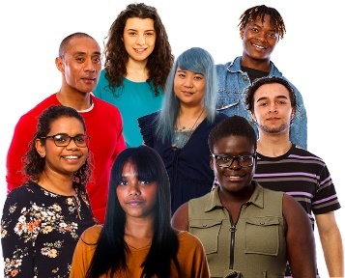 | The way we explain CALD will support:  - all CALD people  and  - their different experiences.
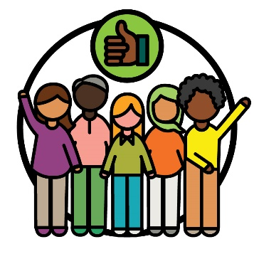 | We will know it is right when CALD communities agree that it is good.
 | We will then update the way we collect data to support how we explain ‘CALD’.
When we talk about data, we mean:
- facts
- information
- records.
We will check if this action is working by the amount of data we collect.
This includes data that supports what CALD participants need.

Action 25
We will research and share new data from CALD participants.
This will support our staff and partners to make good decisions.
 | We will update the way we collect data from CALD participants.
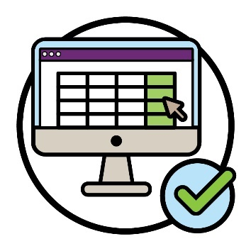 | We will check if this action is working by how many people can use the data we collect about CALD participants.
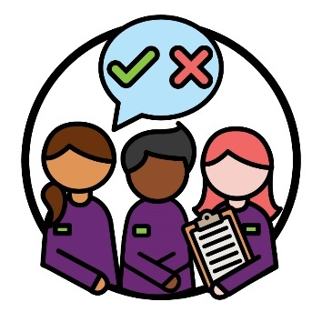 | We will also check if this action is working by listening to how this data affects the way people make decisions.  This includes our staff and partners.

6. How we connect with the community

Action 26
 | We will make a plan about how to share information with CALD communities about:
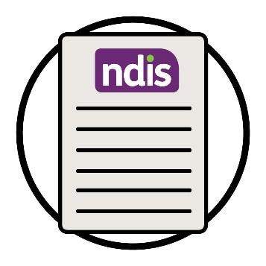 | - the NDIS
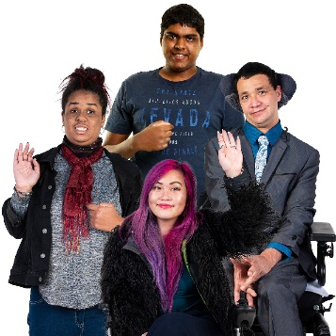 | - the rights of CALD people with disability.
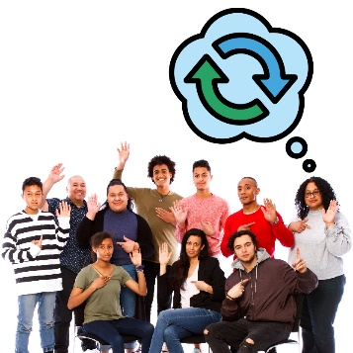 | This plan will help change the attitudes some communities have around disability.  Your attitudes are what you think, feel and believe.
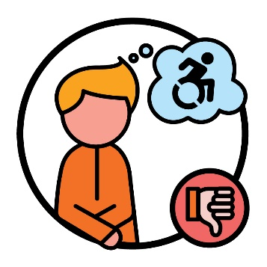 | For example, some people think badly about disability.  This can stop CALD people with disability from using the NDIS.
 | To make this strategy we will work with:
 | - CALD communities
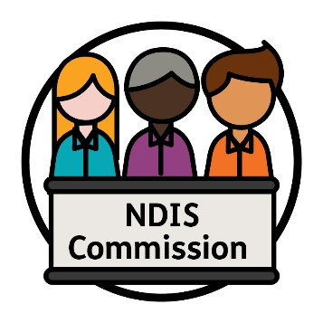 | - the NDIS Commission.
 | We will check if this action is working by how many:
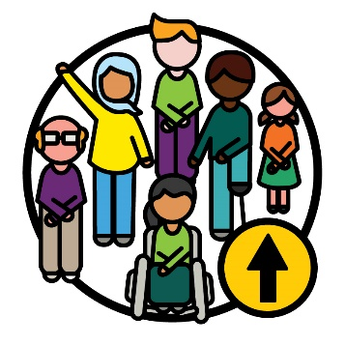 | - CALD participants take part in the NDIS
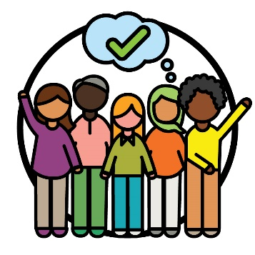 | - CALD communities understand and use the NDIS.

Action 27
 | We will support activities from community organisations that:
 | - share information about the NDIS
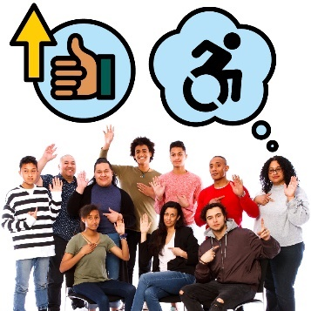 | - improve attitudes about disability in CALD communities.
 | We will check if this action is working by how many CALD communities take part in:
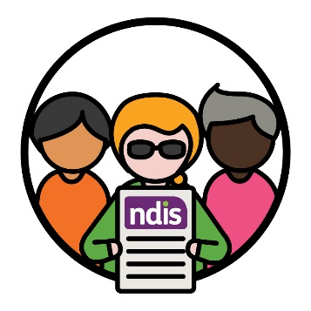 | - the NDIS
 | - activities from community organisations.

 | We will also check if this action is working by how many CALD communities:
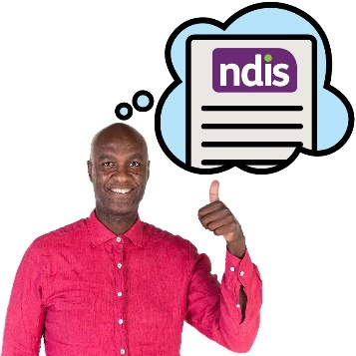 | - understand the NDIS
 | - understand disability
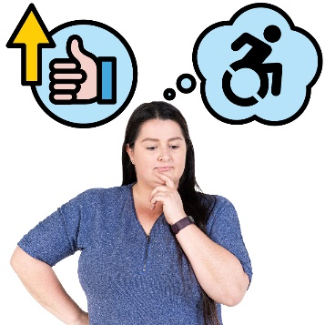 | - have better attitudes towards disability.

Action 28
We will work with community organisations to build the skills of services outside the NDIS.
For example, doctors.
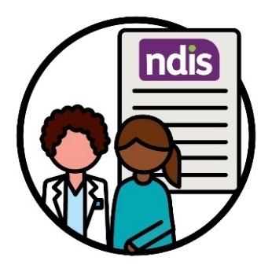 | We will make sure more of these services understand how to support CALD people with disability to take part in the NDIS.
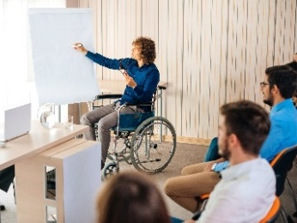 | We will check if this action is working by how many programs we support that help services build these skills.
 | We will also check if this action is working by listening to what:
 | - CALD communities have to say about services that give advice about the NDIS
 | - these services tell us about how well the programs support them.

More information
For more information about this Action Plan, please contact us.
You can visit our website.
www.ndis.gov.au
You can call us.
1800 800 110
You can follow us on Facebook.
www.facebook.com/NDISAus
You can follow us on Twitter.
@NDIS
Twitter is also called X.

Support to talk to us
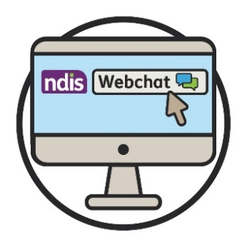 | You can talk to us online using our webchat feature at the top of our website.  www.ndis.gov.au
If you speak a language other than English,
you can call:
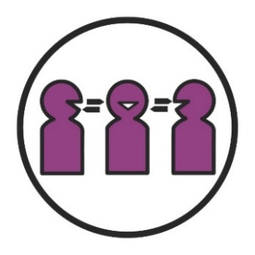 | Translating and Interpreting Service (TIS)  131 450
If you have a speech or hearing impairment,
you can call:
TTY
1800 555 677
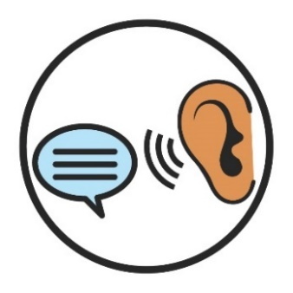 | Speak and Listen  1800 555 727
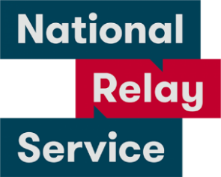 | National Relay Service  133 677  www.accesshub.gov.au/about-the-nrs

Word list
This list explains what the bold words in this plan mean.

Assessments
Assessments are how we work out:
- how your disability affects your life
- what supports you need from the NDIS.
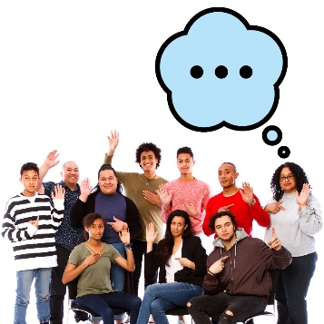 | Attitudes  Your attitudes are what you think, feel and believe.

Barrier
A barrier is something that stops you from doing something you:
- need to do
- want to do.

Career
A career is the path you take in an area of work you choose.

Complaint
When you make a complaint, you tell someone that something:
- has gone wrong
- is not working well.

Cultural safety
Cultural safety is when we:
- respect people’s culture
- make people feel safe
- help people feel like they belong.

Culturally and linguistically diverse (CALD)
CALD people:
- come from different backgrounds
- speak languages other than English.

Culturally appropriate and responsive service
Culturally appropriate and responsive service is when services respect the cultures and beliefs of the people who use them.

Culture
Your culture is:
- your way of life
- what is important to you.

Data
When we talk about data, we mean:
- facts
- information
- records.

Identify
When you identify as something, you are saying that you belong to a certain group of people.

Inclusive
When something is inclusive, everyone:
- can take part
- feels like they belong.

Interpreter
An interpreter is someone who:
- uses your language
- helps you communicate with others
- helps you understand what someone is saying.

NDIA planner
An NDIA planner is someone who:
- makes new plans
- changes plans.

NDIS partners
NDIS partners are people who help others find and use services.

NDIS Quality and Safeguards Commission (NDIS Commission)
The NDIS Commission makes sure people with disability who take part in the NDIS:
- are safe
- get good services.
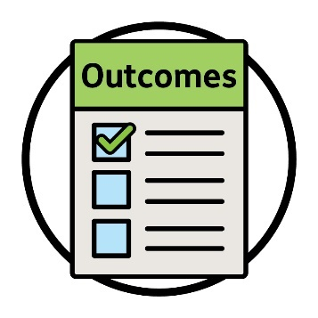 | Outcomes  Outcomes are the ways our work changes people’s lives.

Participants
Participants are people with disability who take part in the NDIS.
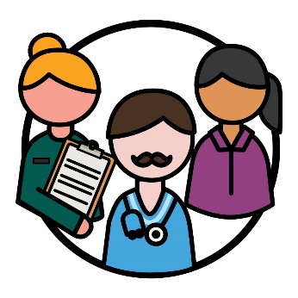 | Providers  Providers support people with disability by delivering a service.

Refugee
A refugee is someone forced to leave their country:
- because of violence
- so they can stay safe.

Rights
Rights are rules about how people must treat you:
- fairly
- equally.
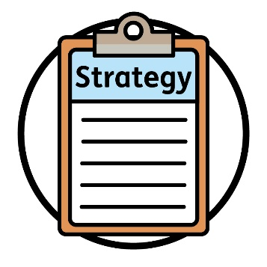 |  | Strategy  A strategy is a plan for how we will make things better.

Trauma
Trauma is the way you feel about something bad that happened to you.
For example, you might feel scared or stressed.
Trauma can affect people in different ways.
 | The Information Access Group created this Easy Read document using stock photography and custom images. The images may not be reused without permission. For any enquiries about the images, please visit www.informationaccessgroup.com. Quote job number 5212-B.

